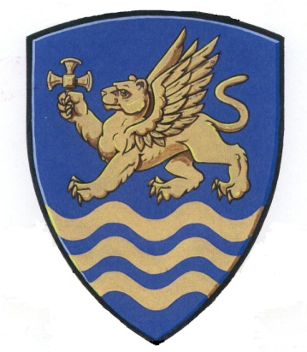
THE ANGLICAN PARISH OF ST. MARK

Reformation, Sunday, 10:00 a.m., October 26, 2025
HOLY COMMUNION - WITH ONE VOICE
Bread of Life, Setting 5

We acknowledge with thanksgiving that we gather to worship on the territories
of the Kwakwaka’Wakw, Nuu-Chah-Nulth and Coast Salish Peoples.
We are grateful for our growing relationship with the Qualicum First Nations.
We commit ourselves to a journey of truth and reconciliation
between the indigenous peoples of this land and the non-native peoples of Canada.

Rector: The Venerable Elizabeth Northcott

Greeters: Bill and Heather Gilbertson

Crucifer: Paul Gillan Reader: Janet Goos
Intercessor: Bob Goos Chalice Bearers: Michael King Susan Cook
Pianist: Pippa Williams

Presider: Rev. Bob Goos

Brief Order for Confession and Forgiveness…………………… Page 10

Gathering Page 28
*Hymn 718 “Here In This Place”
Greeting
Kyrie Page 28

Hymn of Praise Page 29

Prayer of the Day

Gracious Father, we pray for your holy catholic church. Fill it with all truth and peace. Where it is corrupt, purify it; where it is in error, direct it; where in anything it is amiss, reform it; where it is right, strengthen it; where it is in need, provide for it; where it is divided, reunite it; for the sake of your Son, Jesus Christ, our Saviour, who lives and reigns with you and the Holy Spirit, one God, now and forever. Amen.

Word

First Reading: Jeremiah 31:31-34

Psalm 46
1 God is our refuge and strength,
a very present help in trouble.
2 Therefore we will not fear, though the earth should change,
though the mountains shake in the heart of the sea;
3 though its waters roar and foam,
though the mountains tremble with its tumult.
4 There is a river whose streams make glad the city of God,
the holy habitation of the Most High.
5 God is in the midst of the city; it shall not be moved;
God will help it when the morning dawns.
6 The nations are in an uproar, the kingdoms totter;
he utters his voice, the earth melts.
7 The Lord of hosts is with us;
the God of Jacob is our refuge.
8 Come, behold the works of the Lord;
see what desolations he has brought on the earth.
9 He makes wars cease to the end of the earth;
he breaks the bow, and shatters the spear;
he burns the shields with fire.
10 ‘Be still, and know that I am God!
I am exalted among the nations,
I am exalted in the earth.’
11 The Lord of hosts is with us;
the God of Jacob is our refuge.

Second Reading: Romans 3:19-28

Gospel Acclamation Page 31

Gospel Reading John 8: 31-36 Then Jesus said to the Jews who had believed in him,
‘If you continue in my word, you are truly my disciples;
and you will know the truth, and the truth will make you free.’

They answered him, ‘We are descendants of Abraham and have never been slaves to anyone. What do you mean by saying, “You will be made free”?’
Jesus answered them, ‘Very truly, I tell you, everyone who commits sin is a
slave to sin. The slave does not have a permanent place in the household; the son has a place there for ever. So if the Son makes you free, you will be free indeed.

*Hymn 783 “Seek Ye First the Kingdom of God”

Sermon Rev. Faith Brace

*Hymn of the Day 784 “You Have Come Down to the Lakeshore”

Nicene Creed Page 32

The Prayers

Meal
Peace Page 34
Presentation of the Gifts Offertory Page 35
Great Thanksgiving Page 36
Amen Page 38
Lord’s Prayer Page 39
Communion
Lamb of God Page 39

As people commune, you are invited to sing:
*Hymns 701 710 709

Canticle Page 40
Prayer Page 41

Sending
Blessing
*Hymn 651 “Shine, Jesus Shine”

Dismissal
Go in peace. Serve the Lord

Thanks be to God.

ALTAR FLOWERS
Flowers on the altar today are given by Nina Antoniuk to
The Glory of God and the memory of my beloved husband Tony

Socktober

Sock it to me! So far we have collected almost 200 pairs of nice warm socks, 118 from you generous folks at ST. Mark's.
Final day for collecting is November 2nd! Still two locations to check out! These socks make a difference and can reduce foot problems for our unhoused neighbours. This small gift of mercy makes a big difference.
______________________________________________________________________

Food Bank

WE delivered about 200 lbs of food to the Food Bank after Thanksgiving! Thanks to all who shared. The Food bank basket it always there and we are happy to deliver anything you can give. Protein and kids lunch items are always welcome.
______________________________________________________________________________

Christmas Red Kettle Campaign

As holiday season approaches, the Salvation Army is gearing up for the annual Red Kettle Campaign. The kettle and the ringing bells are symbols of hope and good will in the community. The money raised is used for programs such as the food bank and soup kitchen.

If you are interested in participating for a shift at a kettle, please contact Andrea Richardson at 250-905-0319 or mountarrowsmith.kettles@salvationarmy.ca with the dates and hours you would like to participate. The campaign runs from Tuesday November 18th to Monday December 24th excluding Sundays and Mondays.
____________________________________________________________________

HO HO HO!

Mark your calendars! St. Mark’s Christmas Bazaar will be held this year on Saturday, November 29th, from 9-12:00. At this popular event we sell baked goods, especially Christmas treats, jams and jellies, handicrafts and treasures.

There will be a silent auction, café, books, Kay’s cards and Mystery Bottles!
Get involved by signing up on the sheets in the Hall.

If you any questions, speak to Wendy de Candole or email: 4decand@telus.net
or 250-752-5384.
________________________________________________________________

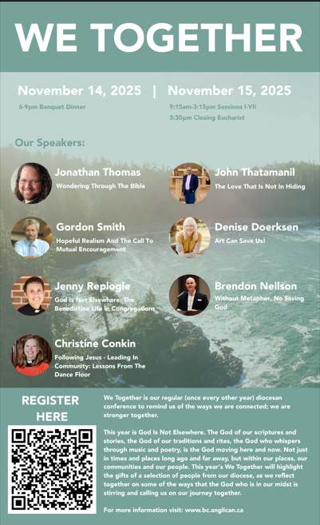

We Together Conference Information
We Together is our regular (once every other year) diocesan conference to remind us of the ways we are connected; we are stronger together. We are bound in countless ways, in our structures, in our prayers, and through the stories we tell. We are each other's concern, and we are each other's gift.
This year's theme is God is not Elsewhere. The God of our scriptures and stories, the God of our traditions and rites, the God who whispers through music and poetry, is the God moving here and now. Not just in times and places long ago and far away, but within our places, our communities and our people. This year's We-Together will highlight the gifts of a selection of people from our diocese, as we reflect together on some of the ways that the God who is in our midst is stirring and calling us on our journey together. We will eat and laugh, we will learn and be challenged, and together we will be nourished for our journey.
The conference will begin on Friday evening November 14th with an evening banquet at St Paul's in Nanaimo followed by an opening address. On Saturday we will gather at St. Paul's for a full day of workshops featuring our speakers John Thatamanil, Jonathan Thomas, Jenny Replogle, Christine Conkin, Brendon Neilson, Gordon Smith, and Denise Doerksen.
For more information visit our website:

https://www.stmarkqualicum.ca/events/we-together-2025/2025-11-14

St. Mark’s Calendar
Oct 27th – Nov 2nd
Monday 27th
11:30am- 3:30pm Alpine Gardeners

Tuesday 28th
9:00am – 3:00pm -Seaside Quilters
9:15am Garden Group
4:00pm- Handbells
6:00pm – 9:00pm- Echo Players

Wednesday 29th

10:00am- 11:00am - Sermon Circle
11:30am – Holy Communion
5:30pm – 7:30pm - Narcotics Anonymous

Thursday 30th
9:00am to 3:00pm – Friendship Quilters
11:15am-Choir Practice
3:30pm -52 Ways to Reconcile
6:00pm to 9:00pm- Echo Players

Friday 31st
9:00am – 3:00pm – Friendship Quilters

Saturday Nov 1st
9:30am Discernment Team
10:00am – 3:00pm -Chess Club

All Saints Day Nov 2nd
8:30am- Holy Communion - BCP
10:00am- Holy Communion – BAS Handbells
1:00pm to 5:00pm- Echo Players

