THE ANGLICAN PARISH OF ST. MARK
“Drawing People to the Light”
Part of the Diocese of British Columbia
www.stmarkqualicum.ca https://bc.anglican.ca
The Second Sunday of Lent
March 1, 2026

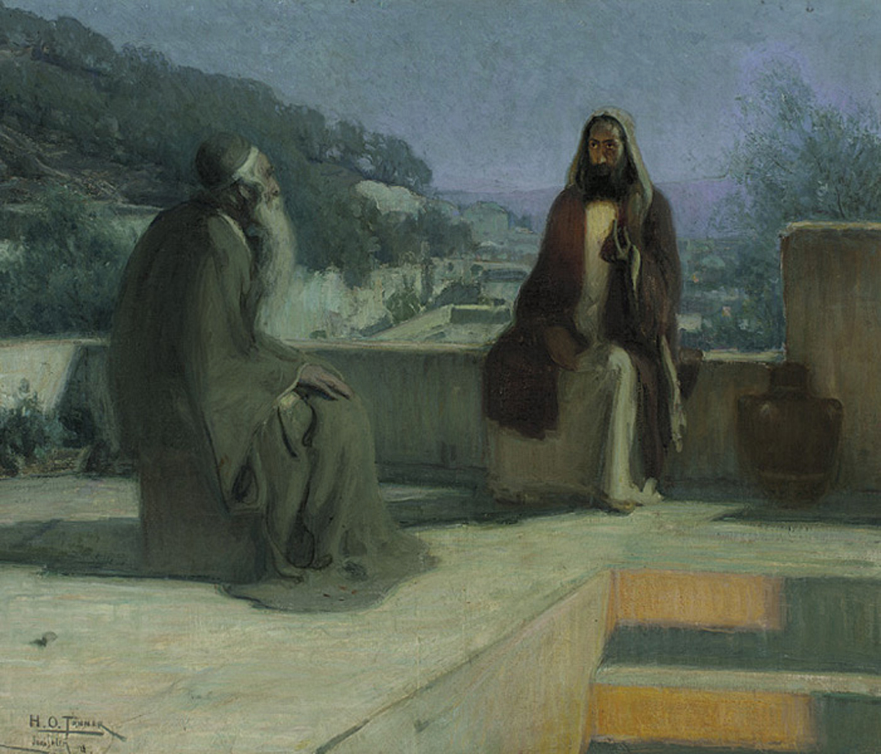

In a state of openness, and with a desire to learn the truth of our shared history, we acknowledge that we worship on the unceded territory of the Qualicum First Nation. We give thanks for their careful stewardship of the forests, rivers, oceans, lands and air, so that we might walk with them and celebrate the gift of the Creator. We commit to a lifelong journey of respectful understanding.

Celebrant: The Reverend Deborah Rivet

Before the service, please observe silence so that we can be in quiet prayer.

Celebrant: The Reverend Deborah Rivet
Before the service, please observe silence so that we can be in quiet prayer.

Opening Sentence: The Son of Man must be lifted up, that whoever believes in him may have eternal life.

Processional Hymn: A Spendthrift Lover is the Lord CP 177

The Gathering of the Community

Celebrant: The grace of our Lord Jesus Christ, and the love of God, and the fellowship of the Holy Spirit, be with you all.
People and also with you.

Celebrant Almighty God,
People to you all hearts are open, all desires known, and from you no secrets are hidden. Cleanse the thoughts of our hearts by the inspiration of your Holy Spirit, that we may perfectly love you, and worthily magnify your holy name; through Christ our Lord. Amen.

Trisagion: Holy God,
(said 3 X) Holy and mighty,
Holy immortal one,
Have mercy upon us.

The Collect of the Day:
Almighty God,
Whose Son was revealed in majesty
Before he suffered death upon the cross,
Give us faith to perceive his glory,
That being strengthened by his grace,
We may be changed into his likeness, from glory to glory; who lives and reigns with you and the Holy Spirit,
One God, now and forever.

The Proclamation of the Word

First Reading: Genesis 12.1-4a
Reader’s Introduction to our first lesson: "In our Lesson today we hear the story of Abraham’s call to leave his home for a new land, a journey of faith and trust that mirrors our own journey through Lent.
A Reading from Genesis:
Now the LORD said to Abram, "Go from your country and your kindred and your father's house to the land that I will show you.
I will make of you a great nation, and I will bless you and make your name great, so that you will be a blessing.
I will bless those who bless you, and the one who curses you I will curse, and in you all the families of the earth shall be blessed."
So Abram went, as the LORD had told him, and Lot went with him.

The Word of the Lord
Thanks be to God

Hymn: Unto the Hills Around Do I Lift Up CP 543

Psalm 121 (said responsively by the whole verse)

I lift up my eyes to the hills-- from where will my help come?

My help comes from the LORD, who made heaven and earth.

He will not let your foot be moved; he who keeps you will not slumber.

He who keeps Israel will neither slumber nor sleep.

The LORD is your keeper; the LORD is your shade at your right hand.

The sun shall not strike you by day nor the moon by night.

The LORD will keep you from all evil; he will keep your life.

The LORD will keep your going out and your coming in from this time on and forevermore.

Second Reading: Romans 4: 1-5, 13-17
Reader’s Introduction: In our second lesson we hear Paul highlight Abraham’s faith, reminding us that we are justified not by our own works, but by the grace and promise of God.

A reading from Paul’s Letter to the Romans:

What then are we to say was gained by Abraham, our ancestor according to the flesh? For if Abraham was justified by works, he has something to boast about, but not before God. For what does the scripture say? "Abraham believed God, and it was reckoned to him as righteousness."

Now to one who works, wages are not reckoned as a gift but as something due.

But to one who does not work but trusts him who justifies the ungodly, such faith is reckoned as righteousness.

For the promise that he would inherit the world did not come to Abraham or to his descendants through the law but through the righteousness of faith.

For if it is the adherents of the law who are to be the heirs, faith is null and the promise is void.

For the law brings wrath, but where there is no law, neither is there transgression.

For this reason, the promise depends on faith, in order that it may rest on grace, so that it may be guaranteed to all his descendants, not only to the adherents of the law but also to those who share the faith of Abraham (who is the father of all of us,

as it is written, "I have made you the father of many nations"), in the presence of the God in whom he believed, who gives life to the dead and calls into existence the things that do not exist.

Gospel Procession: Holy Spirit, Storm of Love CP 603 verses 1,2,3
Reader The Lord be with you
People And also with you.

Reader The Holy Gospel of our Lord Jesus Christ according to John.
People Glory to you, Lord Jesus Christ.

The Gospel: John 3: 1-17 Reader’s Introduction to the Reading: In our Gospel lesson Jesus tells Nicodemus that true life comes from being born again in the Spirit, leading to the ultimate promise that God so loved the world.
Now there was a Pharisee named Nicodemus, a leader of the Jews. He came to Jesus by night and said to him, "Rabbi, we know that you are a teacher who has come from God; for no one can do these signs that you do unless God is with that person. "Jesus answered him, "Very truly, I tell you, no one can see the kingdom of God without being born from above." Nicodemus said to him, "How can anyone be born after having grown old? Can one enter a second time into the mother's womb and be born?" Jesus answered, "Very truly, I tell you, no one can enter the kingdom of God without being born of water and Spirit. What is born of the flesh is flesh, and what is born of the Spirit is spirit. Do not be astonished that I said to you, 'You must be born from above.' The wind blows where it chooses, and you hear the sound of it, but you do not know where it comes from or where it goes. So, it is with everyone who is born of the Spirit." Nicodemus said to him, "How can these things be?" Jesus answered him, "Are you the teacher of Israel, and yet you do not understand these things? "Very truly, I tell you, we speak of what we know and testify to what we have seen, yet you do not receive our testimony. If I have told you about earthly things and you do not believe, how can you believe if I tell you about heavenly things? No one has ascended into heaven except the one who descended from heaven, the Son of Man. And just as Moses lifted up the serpent in the wilderness, so must the Son of Man be lifted up, that whoever believes in him may have eternal life. "For God so loved the world that he gave his only Son, so that everyone who believes in him may not perish but may have eternal life. "Indeed, God did not send the Son into the world to condemn the world but in order that the world might be saved through him.
Reader The Gospel of Christ
People Praise to you, Lord Jesus Christ.

Gospel Procession: Holy Spirit, Storm of Love CP 603 vs 4&5

Sermon: Rev. Deborah
Celebrant: Let us pray.
Holy and gracious God,
as we journey through this Lenten season, grant us the courage of Abraham to trust your leading,and the openness of Nicodemus to receive your grace anew.
Nurture within us the quiet growth of your Spirit,
that we may let go of all that holds us back
and walk more deeply into your light.
Refresh our hearts, renew our minds,
and draw us ever closer to the love
you have revealed in Jesus Christ our Lord.
May the seeds you have planted in us today
take root and bear fruit in due season.
We ask this in the name of the Father,
and of the Son,
and of the Holy Spirit. Amen.

Prayer Response:
People: Lord, in your mercy,
renew us by your Spirit.
Open our hearts to your grace,
strengthen us in faith,
and lead us into the light of Christ. Amen.

Choir Anthem: The Gift of Love Hal H. Hopson
Affirming our Christian Narrative

Presider: Let us affirm our faith in Jesus Christ the Son of God.
People: Though he was divine
he did not cling to equality with God,
but made himself nothing.
Taking the form of a slave,
He was born in human likeness.
He humbled himself
And was obedient to death,
Even death on the cross.
Therefore God has raised him on high,
And given him the name above every name:
That at the name of Jesus,
Every knee should bow,
And every voice proclaim that Jesus Christ is Lord,
To the glory of God the Father. Amen
(cf Philippians 2. 6-11 (from Creating Uncommon Worship by Richard Giles)

Prayers of the People

Confession

Celebrant Dear friends in Christ, God is steadfast in love and infinite in mercy; God welcomes sinners and invites us to this table. Let us confess our sins, confident in God’s forgiveness.
Silence is kept

Celebrant: Most merciful God,
We confess that we have sinned against you in thought, word, and deed, by what we have done, and by what we have left undone. We have not loved you with our whole heart; we have not loved our neighbours as ourselves. We are truly sorry and we humbly repent. For the sake of your Son Jesus Christ, have mercy on us and forgive us, that we may delight in your will, and walk in your ways, to the glory of your name. Amen.

Almighty God have mercy upon you, pardon and deliver you from all your sins, confirm and strengthen you in all goodness, and keep you in eternal life; through Jesus Christ our Lord. Amen.

Celebrant The peace of the Lord be always with you.
People And also with you.

The Commissioning of Parish Council

This morning we would like to officially commission our Parish Council. Our parish council is an elected body of parishioners working to develop, encourage, and support our lay ministries. By listening and responding sensitively to the needs and concerns of all aspects of the parish, the Parish Council will advise the rector on matters relating to the life of the church and its people.

As the community of The Anglican Parish of St. Mark, Qualicum, we believe that those serving on our Parish Council have been called to this ministry by the Holy Spirit and this congregation.

Ephesians 4 says, “And God gave some to be apostles, some prophets, some evangelists, some pastors and teachers, to equip the saints for the work of ministry, for the building up of the body of Christ…”.

This morning we are taking one more step in the building up of the body of Christ. It is our privilege today to affirm and commission you, Wendy, Sue, Wendy, Michael, Nancy, Faith, Sue, Terry, and Richard in your ministry as members of the Parish Council of St Mark. As a congregation we recognize God’s gifting and anointing in your lives for this ministry.

I invite those being commissioned to respond to the following questions with:
Yes, by the grace of God.

Wendy, Sue, Wendy, Michael, Nancy, Faith, Sue, Terry, and Richard

Do you believe that the Lord has led and empowered you to serve in leadership on our parish council? (yes, by the grace of God)

Do you commit to serving faithfully under the guidance of the Holy Spirit? (yes, by the grace of God)

Are you committed to serving the congregation in this task in harmony with our vision and mission for this parish? (yes, by the grace of God)

Are you committed to a life of prayer that will support you in this calling? (yes, by the grace of God)

Will you seek to hear God’s intention for our parish of St. Mark and to do God’s will? (yes, by the grace of God)

I invite the congregation to respond to the following questions with: Yes, by the grace of God.

Do you recognize that the ministry of the Parish Council is to work on behalf of this congregation to provide leadership and guidance on matters relating to the life of the church and its people? Yes, by the grace of God.

Do you believe that the Holy Spirit has called these people to this ministry? Yes, by the grace of God.

Will you assure them of your warm cooperation and support in this calling? Yes, by the grace of God.

Will you sincerely pray for them? Yes, by the grace of God.

Will you, with them, uphold the vision and mission of this parish as we move forward to continue to build up the body of Christ? Yes, by the grace of God.

Wendy, Sue, Wendy, Michael, Nancy, Faith, Sue, Terry, and Richard- I ask that God will bless you in your ministry as Parish Council of St. Mark, Qualicum and that the Holy Spirit will guide and direct you in this most important work.

CONGREGATION: We pledge our continued support and prayer for our Parish Council as well as our work together. May our gracious Lord grant our Parish Council unity and peace as they discern our future and work towards the fulfilling of the body of Christ.

ALL: In our work together may the Lord be honored. May the Church of Jesus Christ be built up as we faithfully follow him into the future He has for us. May the Lord give us all His grace and strength. Amen

Offertory Hymn: Eternal Lord of Love, Behold Your Church CP 174

The Holy Eucharist
Prayer over the Gifts

God of wisdom,
May the light of the eternal Word,
Our Lord and Saviour Jesus Christ,
Guide us to you glory.
We ask this in his name. Amen

Celebrant God is here.
All: The Spirit is with us.

Celebrant Lift up your hearts and minds.
All: We lift them up to God.

Celebrant Let us give thanks to God the Creator.
All: It is right to give our thanks and praise

Celebrant: It is indeed right that we should praise you,
God of love, our source and our fulfillment,
for you create all things and in you we live and move and have our being.
Your wonder is manifest in land and sea and sky.
You made us in your image.
And even though we turn from you,
again, and again, you call us to yourself,
and in every age, promise liberation.
As a mother gathers her children,
you embraced a people as your own,
to nurture them in the way of compassionate love.
You sent Jesus among us,
incarnate of the Holy Spirit and born of Mary.
Jesus revealed your love for all Creation,
and showed us the way of reconciliation.
Having lived among us - Jesus suffered the cross,Died,
And in rising again became the firstborn of the renewed family.
And so as we gather around your table,
With saints of every age and your beloved creation we raise our voices and sing:

All Holy, holy, holy Lord, God of power and might,
heaven and earth are full, of your glory.
Hosanna in the highest. Hosanna in the highest.
Blessed is he who comes in the name of the Lord.
Hosanna in the highest. Hosanna in the highest.

Celebrant To you be glory, almighty God,
because on the night before he died,
Jesus took bread,
when he had given thanks,
he broke it, gave it to his disciples, and said:
Take, eat, this is my body
which is given for you; do this to remember me.
After supper he took the cup;
when he had given thanks,
he gave it to them and said:
Drink this all of you.
This is my blood of the new covenant,
Poured out for you and for many;
do this to remember me.
Great is the mystery of faith.

All: Christ has died, Christ is risen, Christ will come again.

Celebrant: Recalling Christ’s death and resurrection, we ask you to accept this, our sacrifice of praise.
Pour out your Holy Spirit on us gathered here, and on these gifts of bread and wine that we may be fed with the body and blood of your Son.
When all of creation groans, unite us in Christ and give us your hope that we might be strengthened to do your work, as your body in the world. Through Christ our Redeemer, in the power of the Spirit, all praise and glory be yours, Almighty God, now and forever. Amen

The Lord’s Prayer – (sung) David Haas

Celebrant We break the bread of life,
And that life is the light of the world.
All God here among us,
Light in the midst of us,
Bring us to light and life. Amen

Invitation to The Communion Table

Come to this table,
you who have much faith and you who would like to have more;
you who have been to this sacrament often
and you who have not been for a long time;
you who have tried to follow Jesus and you who have failed.
Come, it is Christ who invites us to meet him here.

The Gifts of God for the People of God
Thanks be to God.

The Healing Ministry Prayer Team and Eucharistic Team
will proceed to the Altar first for Communion.
If you would prefer Holy Communion brought to you in the pew, please stand and the Eucharistic Ministers will come to you.

Communion at the Altar Rail commences
with the Choir Members followed by the Congregation

Prayer Ministry
Our healing prayer team invites you to join them to pray or give thanks to God in the narthex (entrance) during or after communion, or in the alcove under the Exit sign after the service. Confidentiality is assured.

Post Communion Hymn: Giver of the Perfect Gift CP 180

Prayers after Communion
Creator of heaven and earth,
We thank you for these holy mysteries,
Which bring us now a share in the life to come,
Through Jesus Christ our Lord.

Celebrant Glory to God,
All whose power, working in us, can do infinitely more than we can ask or imagine. Glory to God from generation to generation, in the Church and in Christ Jesus, for ever and ever. Amen.

Recessional Hymn: Tree of Life and Awesome Mystery CP 179 VS 1,2,3 &6

Dismissal

Liturgical: Go from this place with the cross on your hearts.
Assistant
People: We will empty ourselves with Christ for the life of the world.

For Emergency Pastoral Care please contact:
Morag Atherstone @ 250-248-6353 or Cynthia Preyser @ 250-954-9122

Announcements

- Welcome to all of you who are worshipping with us today. Please join us in the hall following the service for coffee and conversation in the parish hall.

- A note of appreciation to go to Kate Knappett and Jennifer & Terry Roberts for the great “munchies” served to sustain us all at the Vestry meeting last Sunday.

- Starting today, NEW photos of everyone in our parish family will be taken during coffee time to assist us in updating our Parish Family Photo Board in the library/lounge. At the same time, we will be asking you if you wish to have your telephone contact shared with others in the parish. A special thanks to all who gave consent at last week’s Vestry meeting.

- The Prayer Shawl Ministry meets again tomorrow (March 2) at 10:15 -12:00 in the church hall to knit or crochet shawls and share conversation. Please contact Morag Atherstone for more information.

- The 10:00 service on Sunday, March 8 will be Morning Prayer from the Book of Alternative Services, led by Cynthia Preyser.

- Bell practice for the Beaux and Belles handbell choir has changed to 4:00 - 5:00pm on Tuesdays until June 16.

- Please wear your name tag to help us learn others’ names. If you are new, or have misplaced your name tag, please request one by signing up on the clipboard on the narthex cabinet. When done, new tags will be in your mail slot.

- A 6-week Lenten study session based on “The Chosen” video continues each Wednesday with a soup-and-bun lunch following the 11:30 service. Contact Michael King at errege@icloud.com for more information.

- Our Parish Administrator, Marianne, will be on vacation March 10 - 12, returning March 17. There will still be someone in the office Tuesday - Thursday of the week.

- We are respectfully requesting that everyone make an effort to maintain a “Scent-Free” environment at St. Mark’s. Many of our church family have sensitivities to perfume, aftershave and scented hand creams. Your help in keeping our space “neutral” will be greatly appreciated.

- We are in the process of re-organizing the mailbox cubbyholes in the church hall. Please take time to clear your box of accumulating mail. Thanks.

Thank you to those who assisted in the service today.
Celebrant: | Rev Deborah | Greeters: | Ryan and Faith
Crucifer and Liturgical Assistant: | Paul | Reader: | Avis
Chalice: | Morag and Gill | Musical Director: Guitarist: | Pippa  Richard
Intercessor: | Wendy | Altar Guild: | Nancy

St. Marks Calendar
March 2nd to March 8th

Monday March 2
10:15 -12:00 Prayer Shawl Ministry (library)
12:30 – 3:00 Lenten Study

Tuesday March 3
9:00 –3:00 Seaside Quilters
9:15 – Garden Group
4:00- 5:00 – Handbells

Wednesday March 4
10:00- Sermon Circle (Narthex)
11:30- Holy Communion
9:00 – overnight PQHQG Quilters
5:30 NAC

Thursday March 5
9:00 overnight PQHQG Quilters
11:15- Choir
3:30- 52 Ways

Friday March 6th
9:00 – 3:00 PQHQG Quilters

Saturday March 7th

Sunday Mar 8th
8:30 – Contemplative Matins – BCP
10:00 – Morning Prayer – BAS

